**FOR IMMEDIATE RELEASE**

**August 15, 2024**

**Hospice of Greater Cleveland**

**A new partnership between Judson and McGregor Senior Living Communities**

For Judson and McGregor Senior Living Communities, organizational aspirations have always been to provide continuity of care and quality service through our dedicated teams.

After a thoughtful assessment to expand and support the needs of our respective hospice programs for future growth, we are excited to share the news that will significantly benefit our Judson and McGregor Communities.

We are pleased to announce that the two organizations have embarked on a new joint venture. This significant collaboration will expand the range of compassionate services and bring an expanded, dedicated team of professionals to our residents and their families. This strategic partnership, built on the strengths of both organizations, is designed to provide the utmost comfort, dignity, and support to our hospice residents during their end-of-life journey, ensuring a seamless and enhanced experience for all.

As part of our ongoing commitment to growth and innovation, we have sought affiliations that have allowed our organizations to offer collective services, pilot innovative projects, and create new workforce programs. We are confident that our new joint venture will be equally successful.

Hospice of Greater Cleveland will begin its work on August 15, 2024. This partnership reflects the ongoing support of our collective organization and the missions that drive our commitment to seniors in Northeast Ohio.

For more information about Hospice of Greater Cleveland and its Services, visit [www.hospicegreatercleveland.org](http://www.hospicegreatercleveland.org) or contact the individuals listed below.

Contact Information:

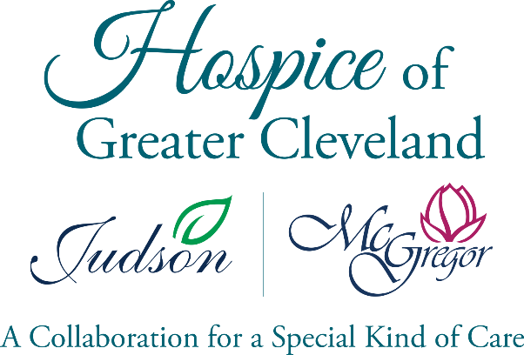McGregor Senior Living

Lee Ann O’Brien

14900 Private Drive

Cleveland, Ohio 44112

(216) 268-8999

Judson Senior Living

Dianna Huckestein

2181 Ambleside Drive

Cleveland, Ohio 44106

(216) 791-2990