**2024 McGregor Service Awards**

We want to extend our heartfelt gratitude to each of you for your unwavering service and commitment to McGregor. Our strength as a community is a direct result of the incredible support and efforts from our staff, and we truly cannot thank you enough.

This summer, we had the privilege of celebrating the 2024 Service Awards, recognizing those remarkable individuals who have dedicated 5, 10, 15, 20, and even 40 years to our mission. It was a wonderful opportunity to come together, bond, and honor the dedication that keeps McGregor thriving.

Thank you for your hard work and loyalty. Together, we continue to make McGregor a great place to work and grow.

**5 Years of Service**

***Cyndy Beal***: Accounts Receivable

***Maria Bowie***: State Tested Nursing Assistant

***Donesha Boyd***: Home Health Aid

***Nakia Bullard***: State Tested Nursing Assistant

***Dwayne Conwell***: Housekeeper, PACE

***Elliott Cruz***: Business Development Director

***Cheri Davis Holmes***: Home Health Aide

***Derrick Gadson***: Van Driver

***Carita Gooden***: Home Health Aide

***Brandon Henderson***: State Tested Nursing Assistant

***Tiana Jackson***: Social Worker

***Monica Lawrence***: Restorative Aide, PACE

***Kimberly Minton***: Manager of Employee Success

***Tina Murphy***: LPN, Gardens

***Kristina Musan***: Nurse Practitioner

***Tamara Strickland***: Home Health Aide

***Shenelle Suggs***: LPN, Assisted Living

***Alena Vlasenko***: Occupational Therapist

***Charles Warren***: Van Driver

***Danielle Weeks***: Home Health Aide

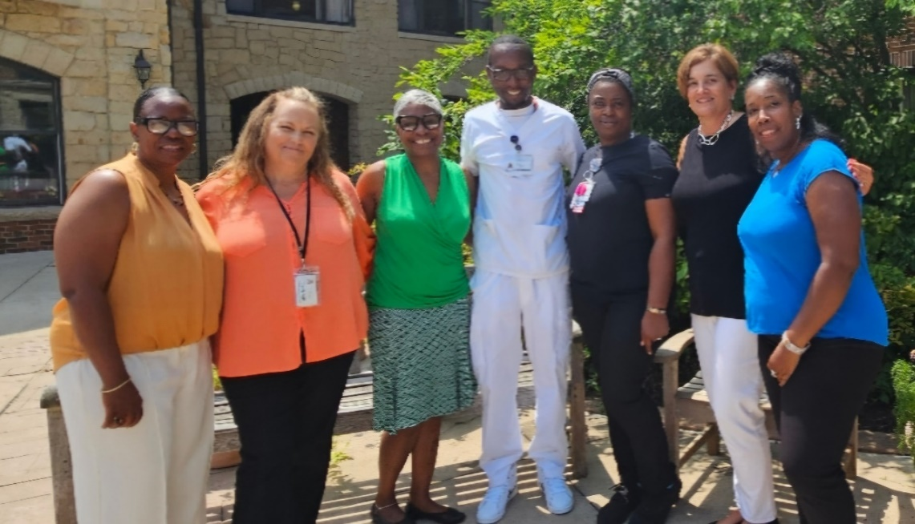

**10 Years of Service**

***Kimberly Bethel***: Care Coordinator Manager, PACE

***Ricardio Johnson Sr.***: Housekeeper

***

**15 Years of Service**

***Rudena Bufford***: Human Resources Manger

***Tangi McCoy***: Chief Executive Officer, PACE

***Delena Rozell-Macon***: Human Resources Generalist

**20 Years of Service**

*Mellody Howard*: LPN, Gardens

***Anjela Shears***: Adult Day Health Center Manger

**40 Years of Service**

***Randolph Prather***: Maintenance Coordinator

